Figures

Created: 2017-12-04 Updated: 2017-12-04

# Sexual Satisfaction by Reported Abuse at Baseline

## Original figure

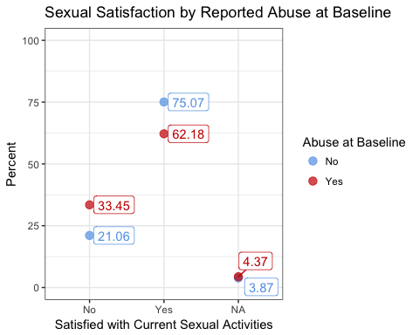

## As a bar chart

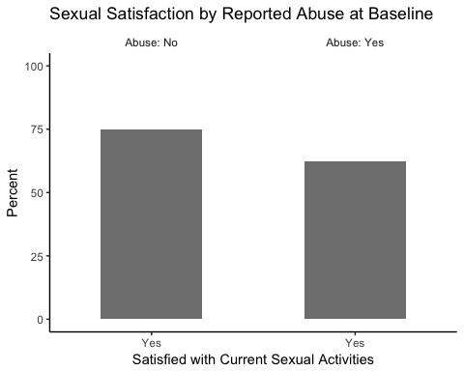

# Sexual Satisfaction by Reported Abuse (4-Category) at Baseline

## Original figure

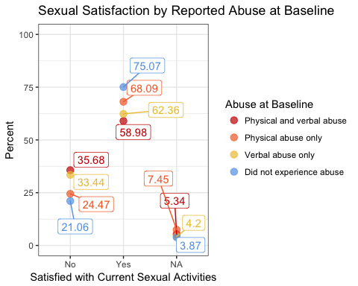

## As a bar chart

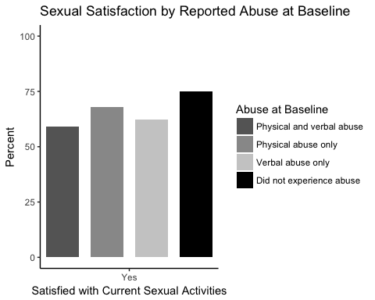

# Sexual Frequency Satisfaction by Reported Abuse at Baseline

## Original figure

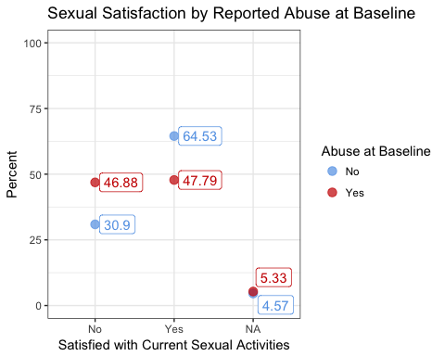

## As a bar chart

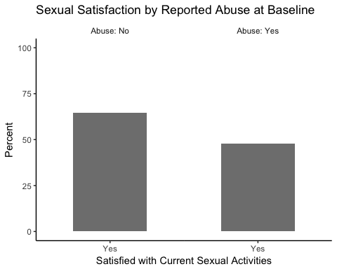

# Sexual Frequency Satisfaction by Reported Abuse (4-Category) at Baseline

## Original figure

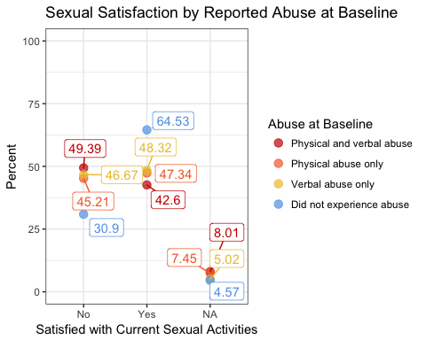

## As a bar chart

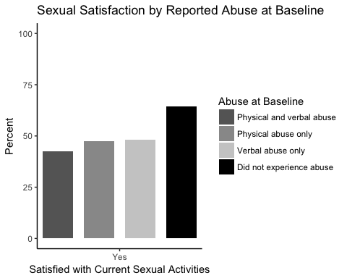

# Percent, and 95% confidence interval, of Women Who Reported Abuse at Baseline by Age Group

## Original figure

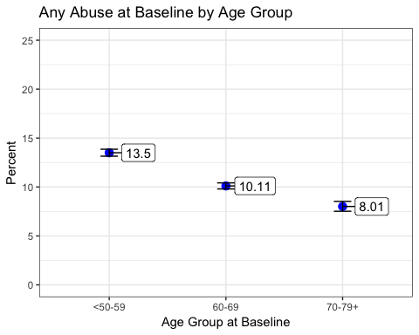

## As a bar chart

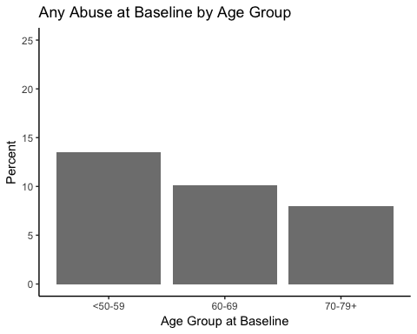

# Percent, and 95% confidence interval, of Women Who Reported Sexual Satisfaction at Baseline by Age Group

## Original figure

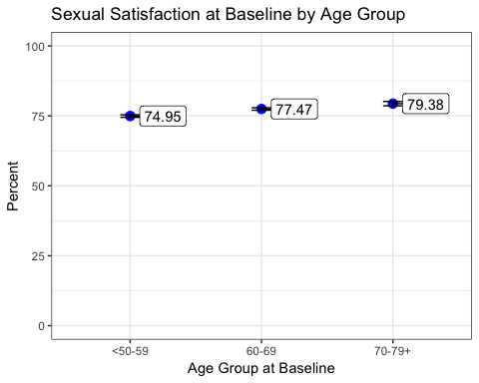

## As a bar chart

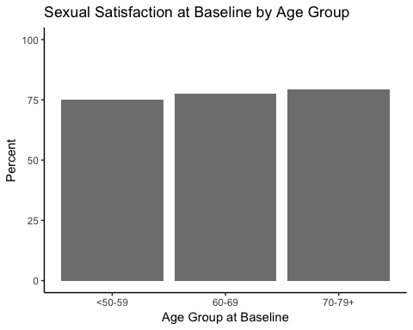

# Percent, and 95% confidence interval, of Women Who Reported Sexual Frequency Satisfaction at Baseline by Age Group

## Original figure

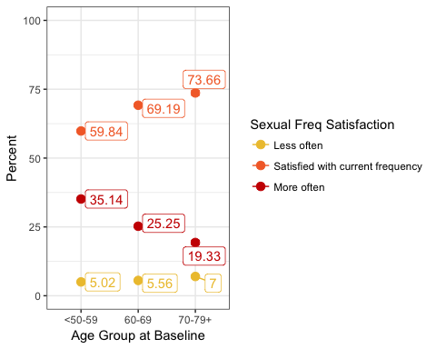

## As a bar chart

